Diocese of Owensboro Summer Feeding Program
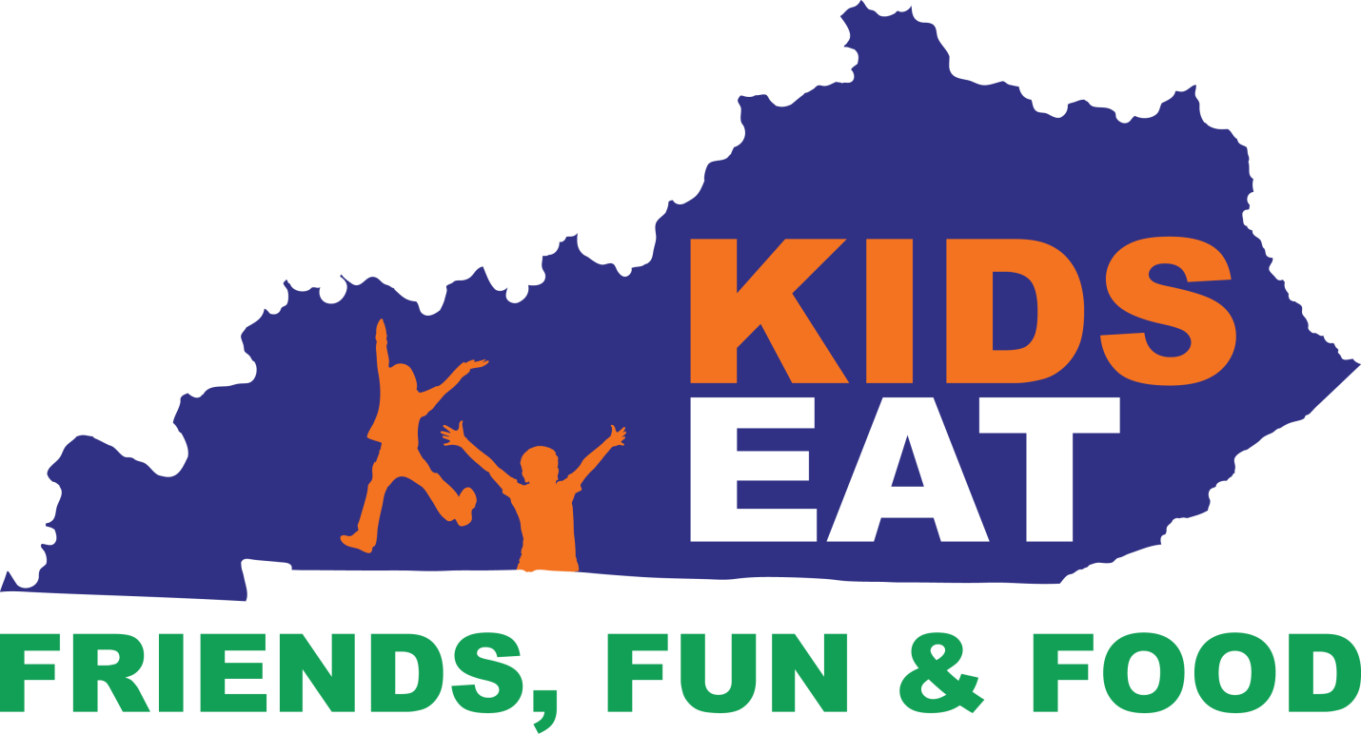

The Diocese of Owensboro Food Service office will be participating in the Summer Feeding Program during summer 2021
Everyone 18yrs & under, private or public schools no matter is encouraged & welcomed to participate in our delicious free lunch program! If you need anything or have questions please contact…
Tricia Canary: 270-315-0205
Tricia.canary@owensborocatholic.org
We Look Forward To Serving You This Summer @ Owensboro Catholic Middle
Drive Thru Style Instructions
Come Around Back Behind The Immaculate Church Keep Going Til You Get Around The 2nd Corner You Will See Signs For Free Lunch Under Carport
Lunch & Next Day Breakfast Served Monday-Friday 11:30am-12:30pm
We will be closed May 21st, May 31st , July 5th & July 27th

