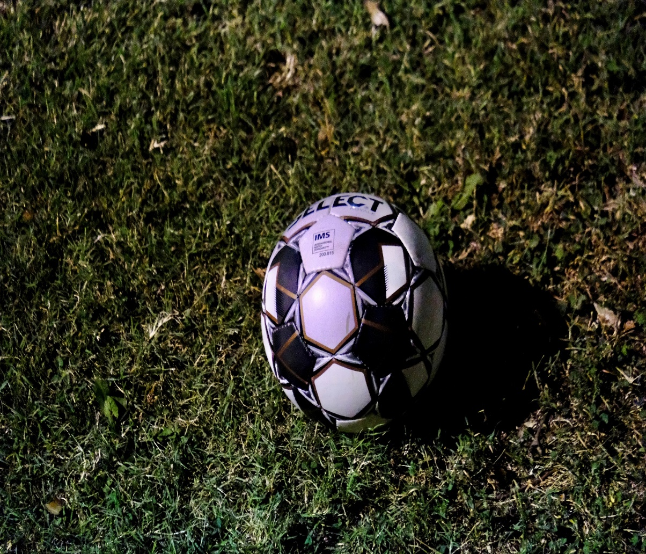
Owensboro Catholic Soccer Program
Andy Donohoe

Long-Term Athlete-Centered Development Model
Introduction
This Long-Term Athlete-Centered Development's (LTACD) objective centers the athlete's personal development running concurrently to talent development with an overall goal of health, happiness, and wellbeing for the duration of the athlete's life. Coaches who allow for the athlete led pathway to the solution, or active participation (Siegler, R. & Ellis, S.,1996) allow the learning structure to be formed within the long-term memory of the child as that structure has been 'built' by the individual child in their vision. The pathway to potential and holistic mindset drives the body of the work noted in the LTACD plan. That potential includes, but is not limited to, the psychosocial development of your child(ren), the evolution of your son's enjoyment of the sport, running concurrently with talent development. Figure 1 (below) highlights the LTACD model in detail. Developmental stages are encased by psychosocial, physical literacy, and Teaching Games for Understanding/ Game Sense (Light, 2013), all of which play pivotal roles in each development stage. Each stage leads to the health and wellness of the participant as it is the main tenant of the LTACD plan.
Periodization
Elite Stage 2:
Maintaining Elite Level Ages 25+ Participation for life/Master Athlete

Perform
Elite Stage 1:
Learning to Elite level Ages 16-24 Participation for life/Master Athlete
Stage 5 Ages 16+ Participation for Life
Learning with Winning (Any age)
Specific

Game Sense Teaching Games for Understanding
Stage 4 Ages 13-16 Participation for Life
Learning with Competition (Any age)
Developmental
Physiological
Psychosocial
Health and Wellness for Life
Stage 3 Ages 10-15 Participation for Life
Learning with Training (Any age)

Stage 2 Ages 6-13
Learning with Fundamentals
Discover Fun Imagine
Figure 1
Basic
Stage 1 Age 3-10
Active Start
Stage 1 Active Start and Discovery Ages 3-10
Active Start and Discovery (see figure 1) is designed for young children taking their first steps into soccer. Built on the 'Discover, Fun, Imagine' ideals, Active Start and Discovery provides young athletes with the foundation of playing with peers, respect for opponents and officials, discovering the fun of playing the sport, creating special moments that endear the child to participating in sports. Basic physical motor skills will be practiced through short games and activities. Fundamental motor skills are vital building blocks in reaching physical literacy (Vealey et al., 2016). Active participation is pivotal to succeeding in providing enjoyment for the athletes. The use of games as a learning tool replaces the monotonous lines and drills traditional at this age. Games designed to be fun, creative, and allow for participants to use their imagination and require consistent physical movement will see great strides gained for the athlete. It is better to create conditions and stimuli from which the kids are drawn to engage in explorative play (Vealey et al., 2016) and not an overly structured practice that invites boredom and monotony. No coach/parent-led focus on competition should be seen in this stage. Kids are naturally competitive (Football Association of Ireland Development Plan, 2015) and will have a desire to win without additional pressure from coaches/parents. Focus on fun and enjoyment and the kids will set the competitive level themselves.
Development Focus/ Benchmarks:
Practices: 1-2 p/w. 60min. Games 3v3-4v4-5v5 with no goalkeepers. 4x6ft goals. 20x25yrd to 30-40yrd field. Physiological Motor Skills: Running, Jumping, Rolling Kicking, Balance Teamwork Concepts: Group Cooperation

Stage 2 Learning with Fundamentals Ages: 6-13yrs
Learning with Fundamentals (see figure 1) continues in the 'Discover, Fun, Imagine' category for how the game and psychosocial environment is presented. Allowing for explorative play/discovery presents the sport as belonging to the participant. This stage overlaps ages with stage 1 Active Start and Discovery, and stage 3 Learning with Training. This is designed to allow for a more individualistic and flexible development plan as players can move through stages when ready rather than a specific age. This allowance provides flexibility for average to late maturation athletes to remain involved in the sport. Again, coach/parent-led focus on competition should not be seen in this stage. Our role as facilitators of the sport is to encourage the athlete and 'catch them being good' rather than too much focus on corrections. Positive feedback strengthens neurological pathways greater than negative feedback (Drueke, B. et al., 2015) so let's catch them being good!
Development Focus/ Benchmarks:
Practices: 2-3 p/w. 60-75min. Games will be4v4-7v7 with GKs. Field size 30x40-70x50 Offensive and Defensive concepts. No position specific specialization. All positions are experienced. Additional Physiological Motor Skills: Lateral Motion, Turning, Body Awareness. Spatial Awareness
Teamwork Concepts: Group Cooperation, Team Building.
“Positive feedback strengthens neurological pathways greater than negative feedback (Drueke, B. et al., 2015) so let’s catch them being good!”

Stage 3 Learning with Training Ages: 10-15
Learning with Training (see figure 1) introduces more formal training into the learning dynamic of the sport. It also factors in an avenue for those with less desire and commitment to the training aspect, allowing for a recreational dimension to the stage. This provides the opportunity for the athlete to continue in the sport they enjoy while gaining the health and psychosocial benefits of playing sport. While stage 3 applies more formal training to the developmental stage, it should not become regimented and must remain flexible with game techniques and tactics supplied in game-like activities. The athlete learner will be at the forefront of the learning process with the coach as a facilitator of this process. The environment created by the coaching staff in the LTACD model must be a physical and phycological safe place for each child that is involved in it. Your child should come away from our program knowing they have coaches that care for them as people and not just athletes in search of winning records etc. Avoidance of dehumanizing opponents or officials begins with the coach's modeling behaviors consistent with respect for all. Both opponents and officials should be viewed as vital elements of the sport (Torres & Hager, 2007). The physical and psychological care of one another should be paramount and supersedes winning.
Development Focus/ Benchmarks:
Practices: 3 p/w. 60-90min Games:9v9-11v11 with GKs. 80x50- 100x65yrds Rules mimic KHSAA/FIFA rules but allow for modification for developmental purposes. Offensive/Defensive concepts. No position specialization. All positions are taught. Physiological Motor Skills: Intro sport specific movements. Strength Development Speed/Agility/Aerobic Development Flexibility Development. Spatial understanding

Stage 4 Learning with Competition Ages 13-16
While competitiveness comes naturally in sports, a healthy view of it is needed as athletes progress. Winning at all cost mentality reduces participants, coaches, and officials to mere pawns where the end is considered more important than the means. Changing this mentality is a focus in this stage. A desire to win is natural and can be considered a given. Coaches should produce a healthy perspective on competition. Athletes should be thought and encouraged to consider opponents, and officials as co-participants of the sport, without whom the game would not be possible. Competition allows for the growth and development of athletes by producing challenges and obstacles. Practices would consist of 3-4 sessions per week, with games built into weekdays and weekends. Each stage should consider that learning is best produced through active participation (Chak, 2001. Ussher et al., 2002) with Teaching Games for Understanding (TGfU) (Light, 2013) continuing to take a prominent role in the development of the athletes. During the Learning with Competition (see figure 1), movements become more sport specific building on the foundational motor movements discussed in previous stages.
While competitiveness comes naturally in sports, a healthy view of it is needed as athletes progress"
Development Focus/ Benchmarks:
Practices: 3-4p/w. 75-90min Games will be 11v11 with GKs. Field size 100x65yrds Rules mimic KHSAA/FIFA rules but allow for modification for developmental purposes. Offensive and Defensive concepts. Position specific specialization introduced with flexibility to change. Physiological Motor Skills: Sport specific movements. Strength Development, Speed/Agility Development, Aerobic/Anerobic Development, Flexibility. Spatial insight.

Stage 5 Learning with Winning Ages: 16+
Learning with Winning (see figure 1) edges itself into the performance side of the sport. While more importance is put on winning, performance and winning should remain in perspective. Winning is important in elite level sports, but must not be considered essential, superseding athletes' care and well-being. No child's well-being should be relegated in priority for performance or winning (Kerr & Sterling, 2008). Additional pressures should be avoided, and the enjoyment and creativity encouraged in stage 1 (Active Start and Discovery) should be mimicked with equal intensity in stage 5. Coaches are facilitators of the game and must be proponents of allowing athletes to remain in love with the sport, enabling the athlete the creative freedom and decision making to develop as a player. Advanced tactical knowledge should be gained through game-like activities, built on the knowledge gained throughout the development of the athlete. The continuation of Teaching Games for Understanding (Light, 2013) provides the athlete with continuity of active participation and guided discovery to advance their understanding of the sport. Stage 5 should also open pathways for athletes to mentor or enter coaching, further spreading the holistic LTACD model message
Development Focus/ Benchmarks:
Practices: 4-5p/w. 75-90min Games: 11v11 with GKs. 100x70yrds. Rules follow KHSAA/FIFA rules. Offensive and Defensive concepts. Position specific specialization. Physiological Motor Skills: Sport specific movements. Strength Development, Speed/Agility Development, Aerobic/Anerobic Development, Flexibility. Spatial excellence.

Elite Stage 1: Learning to Elite level Age 16-24
While each pathway will look unique, empirical evidence suggests the elite and senior-level athlete route to attain and maintain expertise relies heavily on deliberate practice, motivation, social support, and genetic disposition (Starkes & Ericsson, 2003). Learning to Elite level devotes focus to deliberate practice, enhancing and refining development to a distinctive and deliberate focus on soccer specific movements, technique, and tactics. As with all stages of develop, enjoyment is paramount to reduce burnout as time commitment in this stage increases considerably. Enjoyment is this stage can come in many forms and is often delayed with winning and competing events where the enjoyment comes (Starkes & Ericsson 2003). The challenge for athletes wishing to attain expertise can be complex, with genetic factors, social support and motivation all playing pivotal roles in the quest for expertise. Concurrent to these key tenants of expertise is deliberate practice. Deliberate practice is the systematic practice and focus on the specific movements, tactics, physiological and psychological skills of soccer. Such devotion to attaining expertise requires consistent motivation (Wenger, 2020), and those with such intrinsic motivation will have a clear advantage over those who lack such a trait. Following our LTACD model with hopefully aide in the development of such a trait through the development of a passion for the sport. The relationship between coach and athlete is critical at this stage. Coaches act as ‘consultants’ (Brisson, 2003) working concurrently and continuously with the athlete to structure highly concentrated practices to refine technique through repetition, providing feedback alongside motivation for the athlete (Deakin & Cobley, 2003). Practices in this stage must continuously challenge the athlete to invoke true learning as only when the risk of failure is present, and a reality, can athlete actively engage in learning and modifying their skillset (Johnson et. al., 2006). Tactical development is imperative and cumulative from previous developmental stages. In open-skill sports like soccer, tactical decision-making development take considerable time and practice, addressed through mimicking game scenarios (Game Sense (Light, 2013)) and direct instruction from the coach (McPherson & Kernodle, 2003). Practice and training in this developmental stage will be designed to build decision-making knowledge. Such knowledge is required to build and improve action-plan (what we generally do in a situation) and current event profiling (what the immediate scene demands of our response/decision) (McPherson et. al., 2003.) Developing these profiling plans through deliberate practice provides embedded expertise in the athletes long-term working memory. Coaches looking to aide in this development must provide feedback aimed at the athletes decision-making process. Practices that train current event profiling challenge athletes decision-making skillset also encourage visual ‘chunking’, further developing expertise decision-making skills. Competition should be the central influence when developing practice and recovery sessions with practice being designed to lead to optimal performance at the competition.
Development Focus/ Benchmarks:
Practices: 5-7p/w. 60- 90+min Games: 11v11 with GKs. 100x70yrds. Rules follow KHSAA/FIFA rules. Offensive and Defensive concepts. Position specific specialization. Periodization. Physiological Motor Skills: Sport specific movements. Strength Development, Speed/Agility Development, Aerobic/Anerobic Development, Flexibility. Psychological training. Goal Setting.

Practices in this stage must continuously challenge the athlete to invoke true learning as only when the risk of failure is present, and a reality, can athlete actively engage in learning and modifying their skillset (Johnson et. al., 2006).

Elite Stage 2: Maintaining Elite level Age 25+
Entering the elite level of soccer presents its own challenges of maintaining such level of expertise. During peak age of 25-27years (Dendir, 2016) soccer players perform at their optimal level. However, it must be noted that exceptional fitness levels of modern soccer players can push peak performance up to 30years and in some exceptional cases beyond 30years. Maintaining elite performances through deliberate practice and periodization of training methods can give longevity to elite level athletes. The use of sports science with tracking data should be used in the interest of injury prevention and performance. Tracking data (speed, distance, etc.) should be used to design practice plans to allow for optimal recovery and performance. Athlete’s within this stage continue to commit considerable time to improvement of technical, tactical, psychological components of soccer. Maintenance of performance and elite level requires the training program to have flexibility of when to increase and decrease intensity. The coach’s role continues as a facilitator and ‘consultant’ while designing sport specific highly concentrated practice plans in order to continue the athlete’s procedural development of current event profiling and visual chunking (Tenenbaum, 2003). Sessions should cover a wide range of intensity with the overall objective of performing in the game the priority.
Development Focus/ Benchmarks:
Practices: 5-7p/w. 60- 90+min Games: 11v11 with GKs. 100x70yrds. Rules follow KHSAA/FIFA rules. Offensive and Defensive concepts. Position specific specialization. Physiological Motor Skills: Sport specific movements. Strength Development, Periodization, Speed/Agility Development, Aerobic/Anerobic Development, Flexibility. Psychological training. Goal Setting.

Elite Stage 2: Master/Senior Athlete
As athletes move past their peak years, it is important to note that continued expertise performances are frequent throughout the career of the athlete’s and the age-related decline can be tempered through maintenance practice (Starkes, Weir & Young, 2003). Practice tends to narrow and become hyper-specific to the needs and enjoyment of the athlete. Practices times in this stage of the athlete’s career are reduced, yet expertise remains high. Understanding of opponent’s traits, strengths and weakness can be readily identified with deep knowledge base to draw from. Athletes at the elite level can process of information both immediate and anticipatory drawing from their long-term working memory (LTWM) (Tannenbaum, 2003). Such expertise could and should be used by younger aspiring sub-elite and elite athletes through coaching and/or mentoring. Competition during this stage of Master/Senior athlete’s career has many possibilities as more and more master’s circuits have become popular. Social factors continue to play a part in the continuation of the master athletes’ involvement within the sport. Connections built throughout a career play an important role in the life of the athlete and must be considered during this stage.
Development Focus/ Benchmarks:
Practices: 3-5p/w. 60- 90min Games: 7v7 or similar with GKs. 50x35yrds or similar. Rules follow KHSAA/FIFA rules. Physiological Motor Skills: Sport specific movements. Strength Development, Periodization, Speed/Agility Development, Aerobic/Anerobic Development, Flexibility. Psychological training. Goal Setting. Endurance training

It is important to note that continued expertise performances are frequent throughout the career of the athlete’s and the age-related decline can be tempered through maintenance practice (Starkes et. al., 2003).

Conclusion
The Long-Term Athlete-Centered Development (LTACD) plan provides an 'opportunity for all' through all stages of development, intending to provide joyful experiences along with health benefits from active participation. Your child will be part of a holistic approach to soccer that considers the athlete as a 'whole' rather than the focus being weighted to the athletic side. This LTACD model takes a longstanding view of sport participation, allowing the child to realize their potential as an athlete and a person. Furthermore, it builds long-lasting relationships and bonds that transcend the sport, filtering into other aspects of people's lives, potentially extending through society. Athlete-Centered development plans put the athlete at the forefront of learning. Through active participation and guided discovery, the athletes learning, and development becomes the focus and driving force of this LTACD plan. Our hope is for our program to be part of your child(ren) live(s) as they grow and develop through their life and that the experiences gained through participation are positive and long-lasting. Our LTACD plan is designed from the youngest ages to the senior athlete with the athlete central to the learning experience. While not every athlete will reach the elite stages of development, our goal is to produce a program that provides that opportunity while delivering a holistic positive experience for each child, adolescent, and adult that is involved in our program.

“Your child will be part of a holistic approach to soccer that considers the athlete as a 'whole' rather than focus being weighted to the athletic side”

References
Admin. (2020, January 13). Arsene Wenger's Motivational Handout. Retrieved February 15, 2020, from https://soccer-training-info.com/wenger_motivational_handout/
Beilock, Sian L, et al. “Memory and Expertise: What Do Experienced Athletes Remember.” Expert Performance in Sports, Human Kinetics, 2003.
Brisson, (2003). Tactics, the Neglected Attribute of Expertise. In Expert Performance in Sports (pp. 137–167). Champaign, IL: Human Kinetics.
Chak, A. (2001). Adult sensitivity to children’s learning in the zone of proximal development. Journal for the Theory of Social Behavior, 31(4), 383-395.
Côté, J. & Vierimaa, M. (2014). The developmental model of sport participation: 15 years after its first conceptualization. Science and Sport, 295, 563-569.
Deakin, J. M., & Cobley, S. (2003). A Search for Deliberate Practice. In Expert Performance in Sports (pp. 115–135). Human Kinetics.
Dendir, S. (2016) When do soccer players peak? A note. Journal of Sports Analytics 89–105
Duerden M. D. & Witt, P. A. (2010). An ecological systems theory perspective on youth programming. Journal of Park and Recreation Administration, 29(2), 108-120.
Dreuke, B. Weichert, L. Forkmann. Mainz, V. Gauggel, S. Boecker, M. (2015). Neural correlates of positive and negative performance feedback in younger and older adults. Behavioral and Brain Function. US
Johnson, M. B., Tenenbaum, G., & Edmonds, W. A. (2006). Adaptation to physically and emotionally demanding conditions: the role of deliberate practice. High Ability Studies, 17(1), 117–136. National Library of Medicine National Institutes of Health.
Football Association of Ireland Player Development Plan Coach / Parent Workshop, retrieved from https://www.fai.ie/domestic/coach-education/player-development-plan-coach-parent-workshop
Ford, P., De Ste Croix, M., Lloyd, R., Meyers, R., Moosavi, M., Oliver, J., Till, K., Williams, C. (2011). The long-term athlete development model: Physiological evidence and application. Journal of Sport Sciences, 29(4), 389-402.
McPherson, S. L., Kernodle, M. W., & Brisson, T. (2003). Tactics, the Neglected Attribute of Expertise. Expert Performance in Sports (pp. 137–167). Champaign, IL: Human Kinetics.
Siegler, R. S. & Ellis, S. (1996). Piaget on childhood. Psychological Science, 7(4), 211-215.
Starkes, J. L., Weir, P. L., & Young, B. W. (2003). Retaining Expertise. In Expertise in Sports (pp. 252–272). Champagne, IL: Human Kinetics.
Starkes, J. L. & Ericsson, K.A. (2003). Expert Performance in Sport. Champaign, IL: Human Kinetics.
Tenenbaum, G. (2003). Expert Athletes: An Integrated Approach to Decision Making. Expert Performance in Sport (pp. 192–217). Champagne, IL: Human Kinetics.
Ussher, B. & Gibbs, C. (2002). Vygotsky, physical education and social learning. Journal of Physical Education, 35(1), 76-86.
Vealey, R. S., & Chase, M. A. (2016). Cultural competence in youth sport. In Best practice for youth sport (pp. 277-297). Champaign, IL: Human Kinetics
Vella, S. Oades, L, & Crowe, T. 2013. The Relationship Between Coach Leadership, The Coach-Athlete Relationship, Team Success, and the Positive Developmental Experiences of Adolescent Soccer Players. Physical Education and Sport Pedagogy Vol 18, No.5 549-561
McRae, D. Apr 23 2018. Jürgen Klopp: 'I have this helping syndrome. I really care about people'. The Guardian. Retrieved from https://www.theguardian.com/football/2018/apr/23/jurgen-klopp-liverpool-champions-league-roma-mo-salah-brexit
Kerr, G. Stirling, A. (2008). Child Protection in Sport: Implications of an Athlete-Centered Philosophy. National Association for Kinesiology and Physical Education in Higher Education. (60) 307-323.
Lang, M. & Light R. (2010). Interpreting and implementing the long-term athlete development model: English swimming coaches' views on the (Swimming) LTAD in practice. International Journal of Sport Science & Coaching, 6 (2).
Light, R. (2013). Game Sense: Pedagogy for performance, participation, and enjoyment. New York, NY: Routledge
Sport for All, Play For Life, the Aspen-Institute retrieved from https://assets.aspeninstitute.org/content/uploads/2015/01/Aspen-Institute-Project-Play-Report.pdf?_ga=2.228923292.1254449834.1542746412-1583432143.1542636373
Us Youth Soccer. (2012) A Player-Centered Curriculum for US Youth Soccer Clubs
US Youth Soccer Coaching Education Department. http://www.wenatcheesoccer.com/doclib/US_Youth_Soccer_Player_Development_Model.pdf

