Funeral Mass for Fr. Joseph mills
April 8, 2020 | Diocese of Owensboro | St. Stephen Cathedral

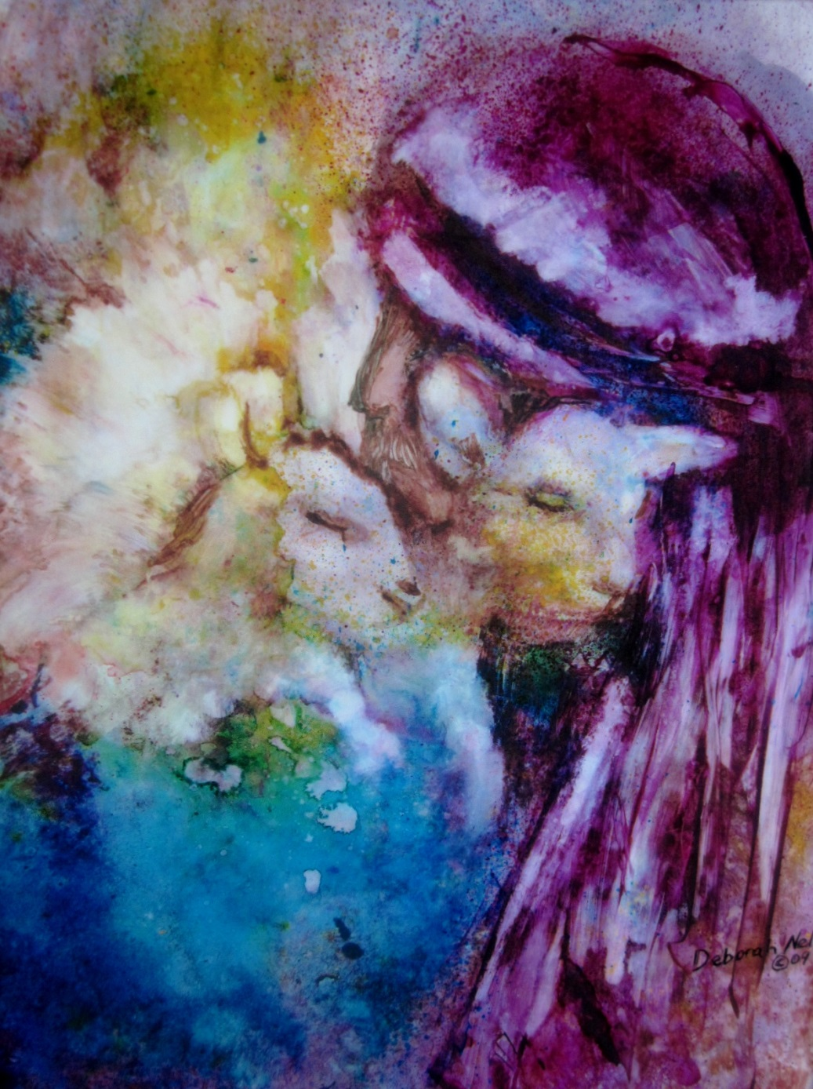

The Good Shepherd, Deborah Nell, 2010. Used with permission of the artist.

Introductory Rites

JESUS, REMEMBER ME
Jesus, remember me when you come into your Kingdom.
Jesus, remember me when you come into your Kingdom.

Placing of the Pall

Procession
BE NOT AFRAID
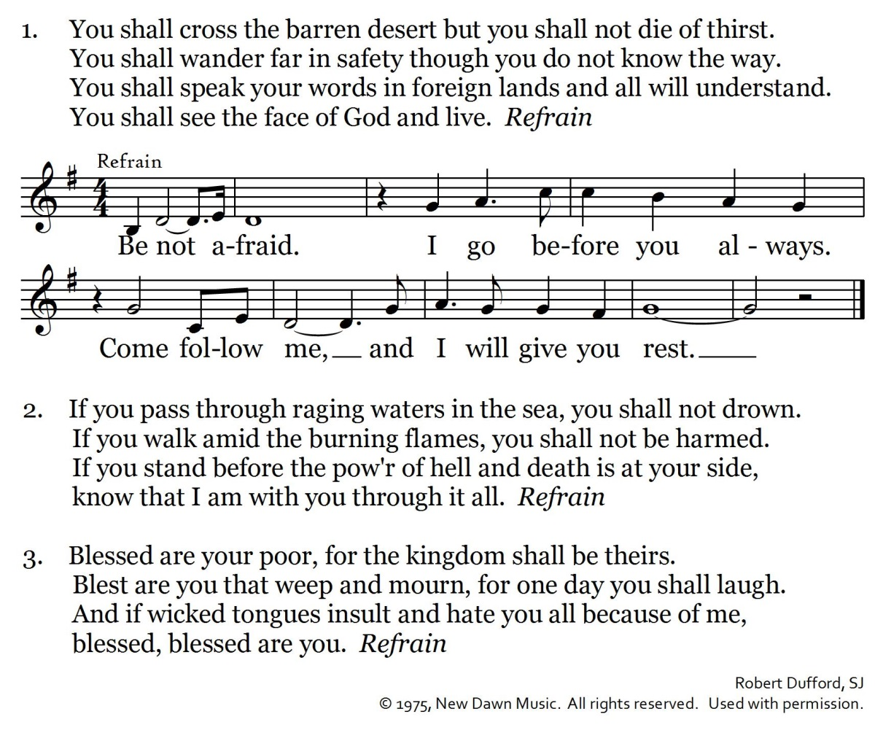Opening Prayer

Liturgy of the Word

Reading Isaiah 25:6a, 7—9

Responsorial Psalm (Psalm 23)

Marty Haugen, © 1988, GIA Publications, Inc. All rights reserved.
Used with permission under OneLicense.net A-702421.

Reading Romans 8:31—35, 37—39

Gospel Acclamation
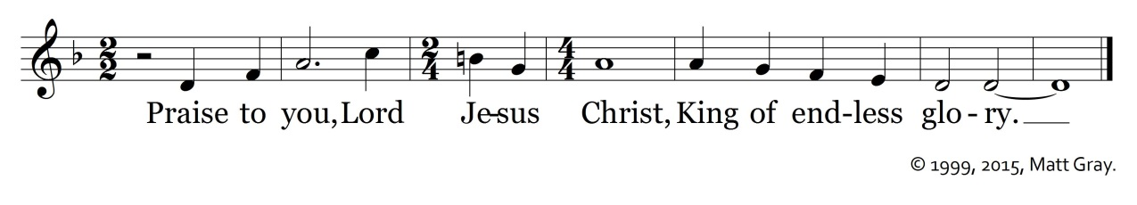
Gospel John 15:9—17

Homily

Prayer of the Faithful

Liturgy of the Eucharist

Preparation of the Gifts
YOU ARE MINE
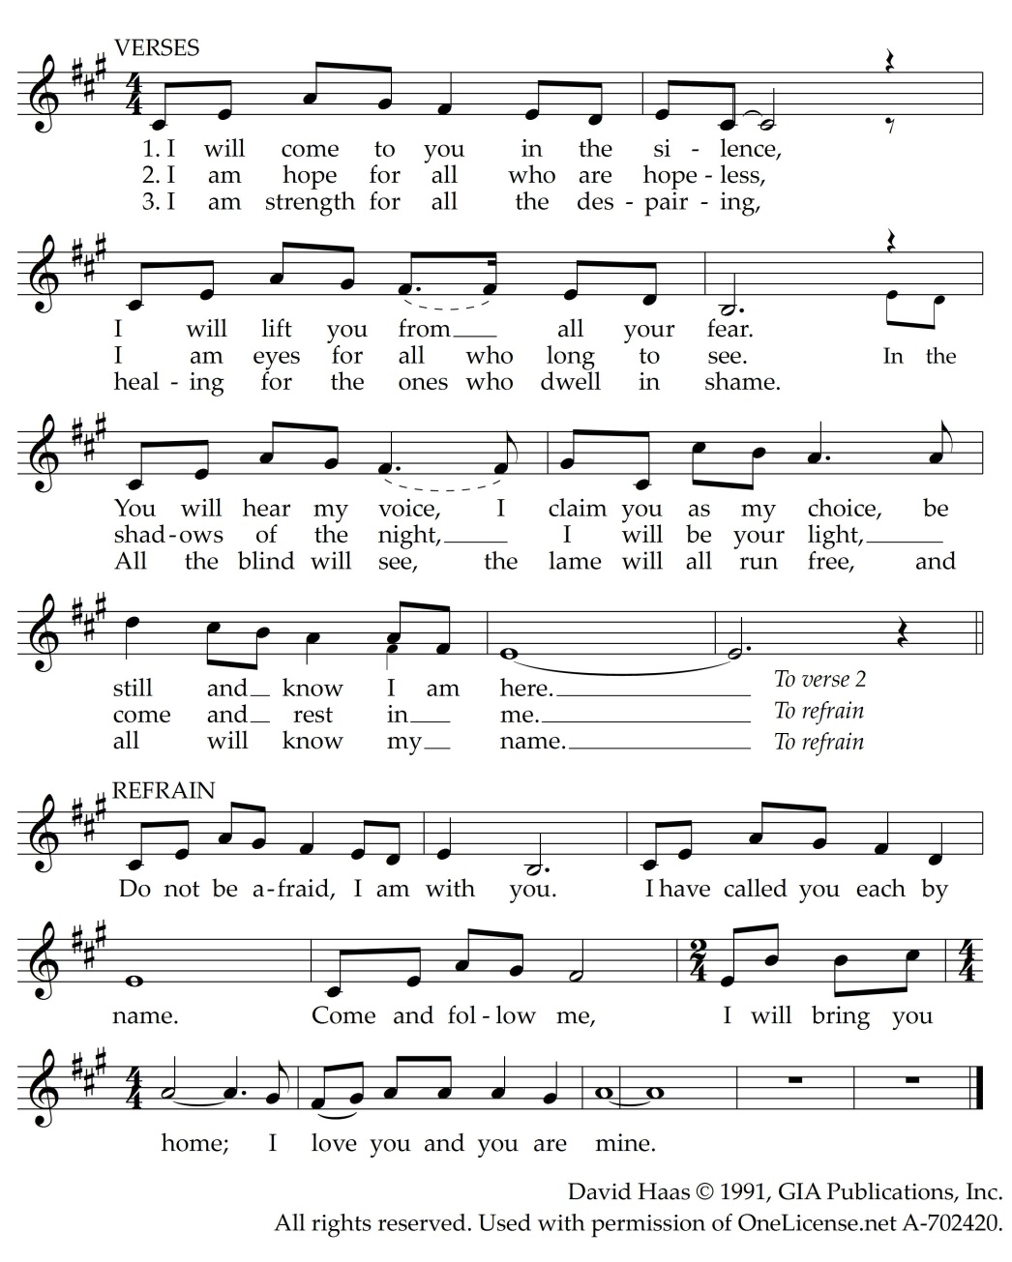

Presider: Pray . . . the almighty Father.
Assembly: May the Lord accept the sacrifice at your hands
for the praise and glory of his name,
for our good and the good of all his holy Church.

EUCHARISTIC PRAYER

Presider: The Lord be with you.
Assembly: And with your spirit.
Presider: Lift up your hearts.
Assembly: We lift them up to the Lord.
Presider: Let us give thanks to the Lord our God.
Assembly: It is right and just.

Holy, Holy, Holy
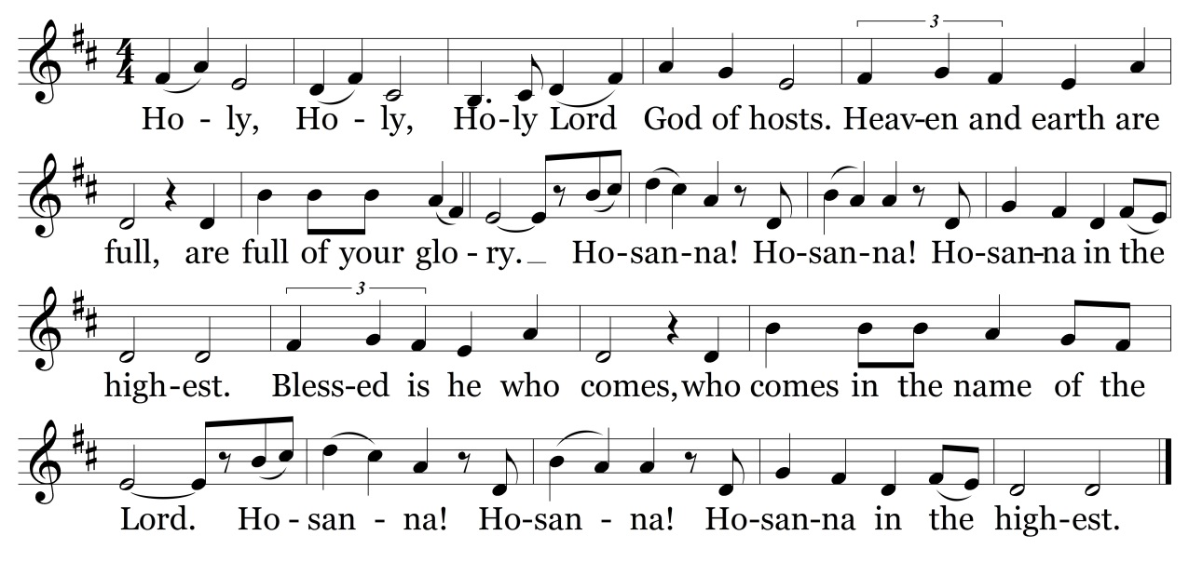

We Proclaim Your Death

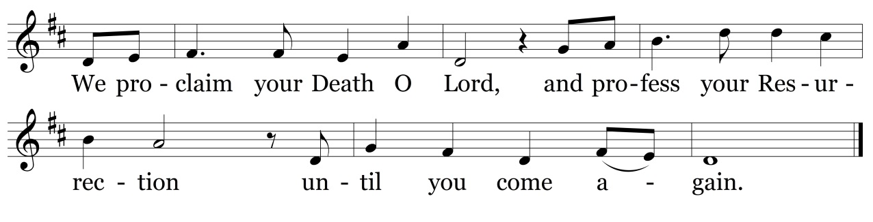

Great Amen
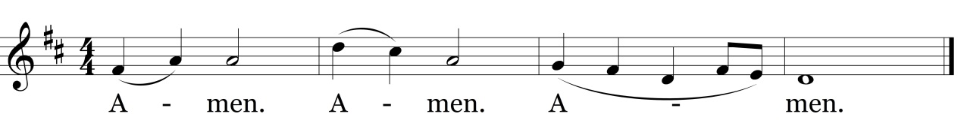

Mass of Christ the Savior, Daniel Schutte, © 2010, OCP.

The Lord’s Prayer
Sign of Peace
Invitation to Holy Communion

Presider: Behold . . . supper of the Lamb.
Assembly: Lord, I am not worthy
that you should enter under my roof,
but only say the word
and my soul shall be healed.

Lamb of God
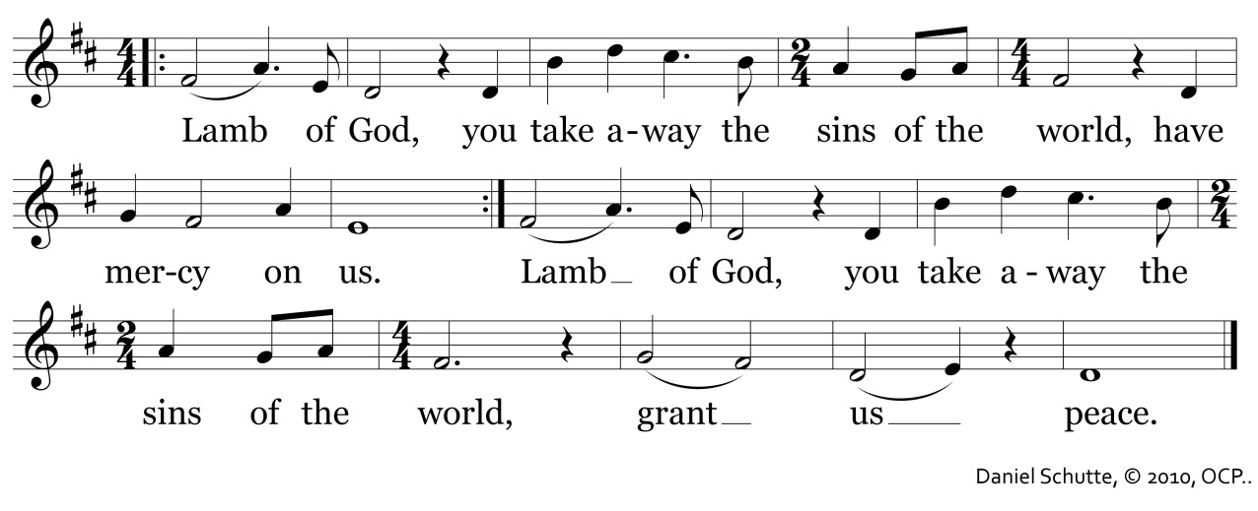
Communion
ON EAGLE’S WINGS
You who dwell in the shelter of the Lord, who abide in his shadow for life,
Say to the Lord: “My refuge, my rock in whom I trust!”
And he will raise you up on eagle’s wings,
Bear you on the breath of dawn,
Make you to shine like the sun,
And hold you in the palm of his hand.
The snare of the fowler will never capture you, and famine will bring you no fear;
Under his wings your refuge, his faithfulness your shield.
And he will raise you up…
You need not fear the terror of the night, nor the arrow that flies by day;
Though thousands fall about you, near you it shall not come.
And he will raise you up…
For to his angels he’s given a command to guard you in all of your ways;
Upon their hands they will bear you up, lest you dash your foot against a stone.
And he will raise you up…

Jan Michael Joncas, © 1979, OCP.

Rite of Commendation

SONG OF FAREWELL
Come to his aid, O saints of God; Come, meet him, angels of the Lord.
Receive his soul, O holy ones;
present him now to God, Most High.
May Christ, who called you, take you home,
and angels lead you to Abraham. Receive his soul…
Give him eternal rest, O Lord. May light unending shine on him.
Receive his soul…
Dennis Smolarski, SJ, © 1981.

Concluding Hymn
LORD OF ALL HOPEFULNESS
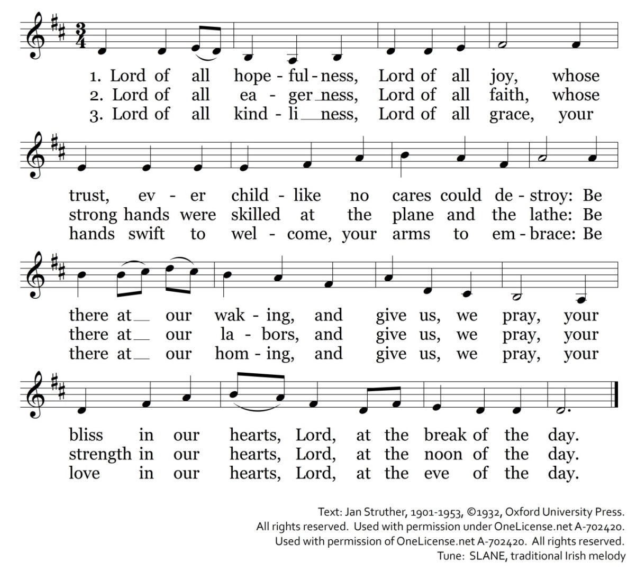

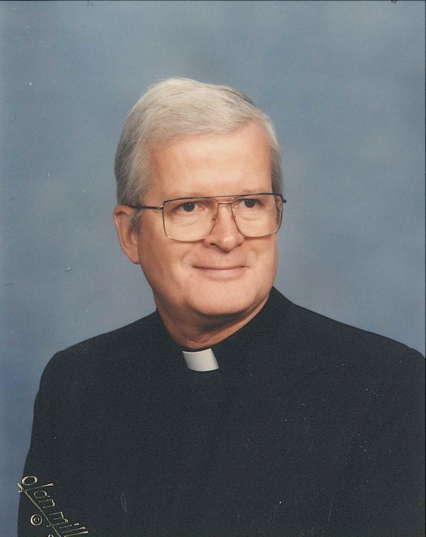

The Rev. Joseph M. Mills
Owensboro, passed away at the Carmel Home on Saturday, April 4, 2020. He was 92 years old.

Fr. Mills, son of the late L.K. and Helen Mills, was born in Owensboro on September 6, 1927. He attended St. Francis Academy for nine years, prior to entering the minor seminary at St. Meinrad Seminary in Indiana in 1942, where he studied for four years.

Fr. Mills continued his studies at the Theological College at Catholic University of America in Washington, D.C., until his ordination by Bishop Francis R. Cotton at St. Stephen Cathedral in Owensboro on May 26, 1953. He served as assistant pastor at St. Agnes Parish, Uniontown, and was then sent to Rome to pursue studies in canon law. Returning to Owensboro in 1961, Bishop Henry Soenneker assigned Fr. Mills to Brescia College where he taught theology for 12 years. In 1973 he was transferred to Holy Spirit Parish in Bowling Green where he served as pastor for nine years. Following a brief pastorate at Precious Blood Parish, Bishop John McRaith appointed him judicial vicar in 1983 and moved him to St. Anthony Parish, Browns Valley, as pastor. In 1992, Bishop McRaith appointed him vicar general, a post he held for nine years. In 1989, he became pastor of St. Martin Parish, Rome. After 11 years, Fr. Mills became chaplain to the Ursuline Sisters of Mount Saint Joseph in Maple Mount. Upon his retirement on January 1, 2004, Fr. Mills continued to minister to the Ursuline Sisters at the Mount.

Besides his multiple years as a pastor, Fr. Mills served on the Priests' Council, the Priest Personnel Committee, and the Diocesan Review Board. He worked with Cursillo, the charismatic renewal, RENEW, Marriage Encounter, Jesus Caritas, and the Serra Club as chaplain. He was a member of the Board of Overseers at St. Meinrad, as well as a board member of the Alumni Association at St. Meinrad. He was a member of the Brescia University Board of Trustees, an Ursuline Associate, and a Passionist Oblate. Fr. Mills was a member of the Canon Law Society of America since he assumed the role of judicial vicar. Besides his seminary training, and his studies in Rome, Fr. Mills attended Loyola University, and did a sabbatical at Notre Dame University.

He was preceded in death by his siblings Randall; Kay; Sister Miriam Ann, CP; and Mollie. He is survived by his brothers Jack and Bill, as well as several nieces and nephews, and great-nieces and great-nephews.

Expressions of sympathy in memory of Fr. Mills may be made to the Retired Priests Fund, 600 Locust St. Owensboro, KY, 42301.

